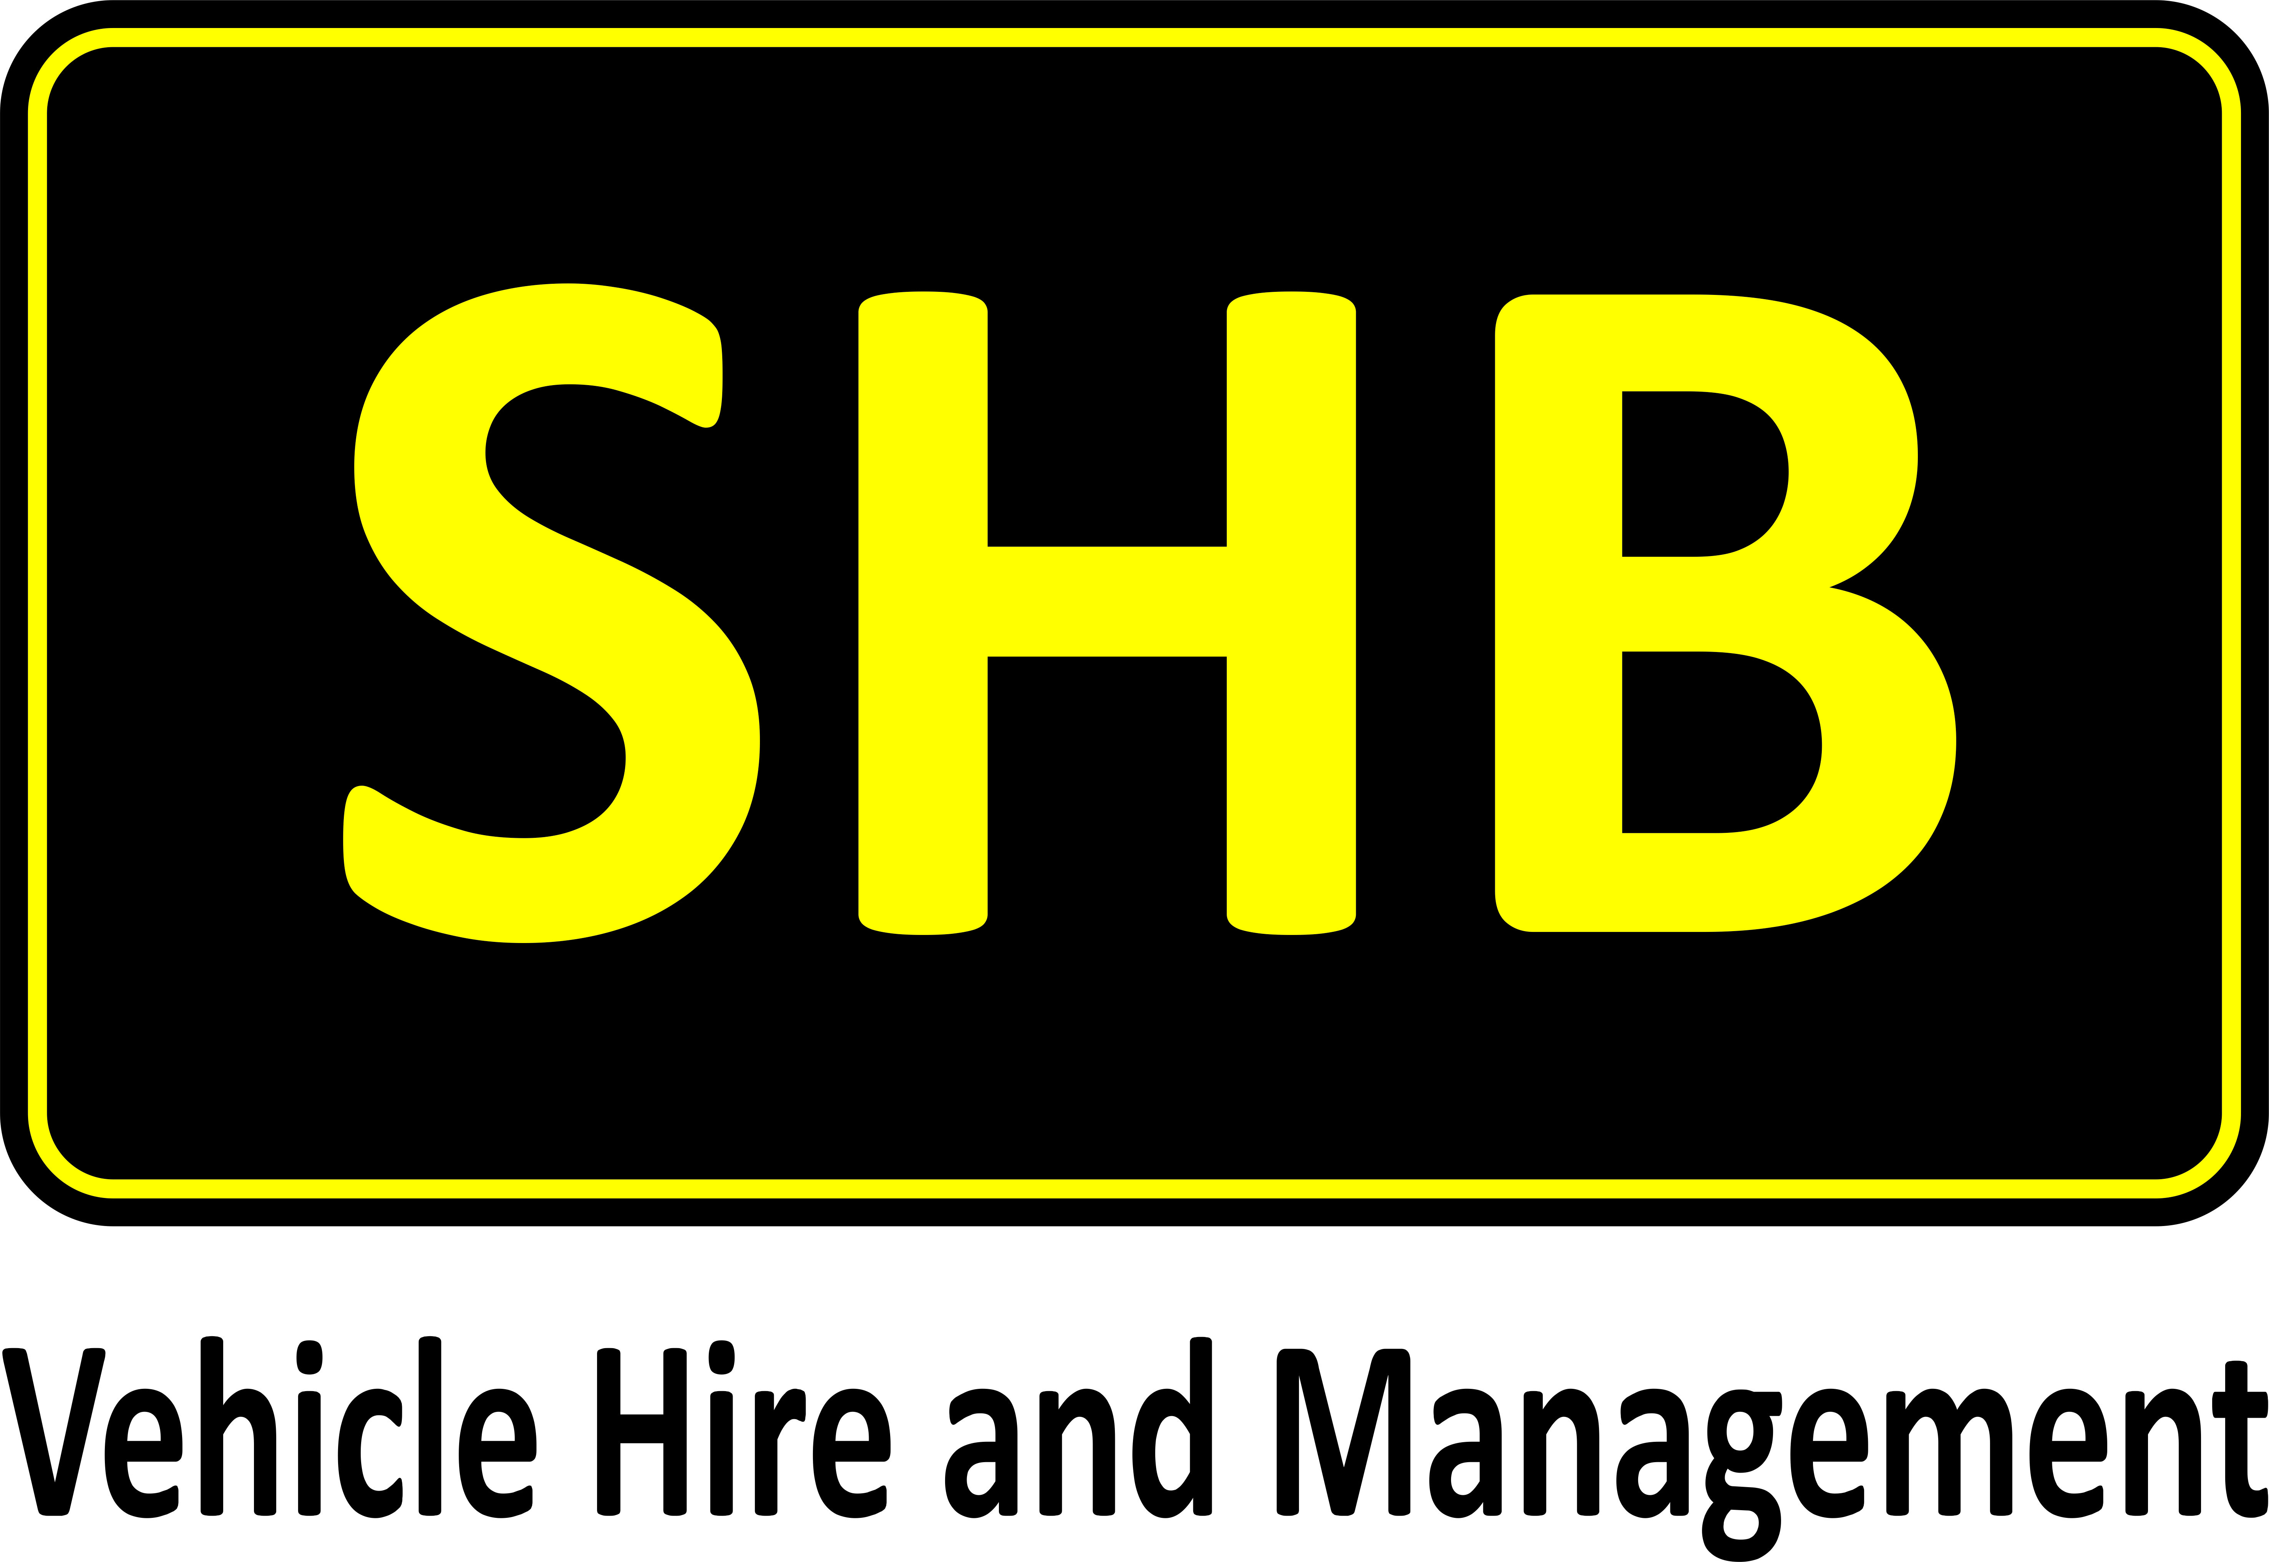

**Dear Acklea Customer**

Following an in-depth review of their business and how to best offer the right level of investment to be able to grow and cement their standing as the UK’s Leading Provider of Traffic Management, Dave Phizacklea and Martin Potter have sold the Acklea business to SHB Hire Ltd, the specialist Vehicle Hire and Management company from the 1 November 2016.

Acklea will continue to operate from its base in Calne and deliver customer excellence to the Traffic Management market as a division of SHB. Dave Phizacklea and Martin Potter will remain involved in the business; Dave on a consultancy basis and Martin as General Manager.

Both companies are focused on delivering solutions with a strong emphasis on operator and equipment safety. Bringing together the companies takes advantage of the teams’ skills, specialist knowledge and extensive vehicle portfolios. This means they can offer the customer a leading one-stop-shop Highway solution.

Commenting on the acquisition Managing Director, Paul Street, of SHB said, “We are delighted to have had this opportunity to bring together two very strong companies, allowing us to leverage years of experience and skills from the teams.

Acklea have a fantastic product in the Traffic Management vehicles they produce, which are designed and built in Calne, and by adding this to our already strong rental offering for the Highways sector we have cemented our place as the leading UK provider.”

Acklea Director, David Phizacklea, said, “Acklea has been at the forefront of the UK Traffic Management Vehicle Industry with our vehicle designs and equipment and we are delighted to be able to grow our business with the support of a national company who is in a position to invest and grow the business and offer broad opportunities for our employees. SHB was a perfect fit for our company values and vision for the future.”

Regardless of the acquisition, this is very much business as usual but with the combined capabilities it’s a chance for current and future customers to really benefit from further investment into the business and the support of SHB’s UK infrastructure and support network.

**Information on SHB**

SHB Hire Ltd is a family owned and operated company with nearly 50 years’ experience of hiring specialist vehicles. They have one of the UK’s largest and most diverse hire fleets with circa 14,500 vehicles and plant. SHB have Europe’s largest 4x4 hire fleet and are able to provide customers with equipment on short, flexi, long term and contract hire for cars, standard and specialist LCVs and HGVs plus specialist units such as traffic management, barrier rigs, road surfacing, welfare, mobility, refrigeration and many more.

SHB offer end-to-end fleet management and consultancy with solutions tailored to meet the customer operating demands with a focus on vehicle optimisation. They can provide packages from simple fleet administration, repair and maintenance, accident management, telematics to complete fleet management outsource.

SHB currently operate out of 14 key locations covering the UK, as their client base grows they continue to expand their geographical footprint and continuously review opportunities for new depots or shared sites with their clients to support operations.

Their speciality is their flexibility and ability to adapt and create bespoke solutions to meet customer requirements to include buy and lease back options, new and older fleet, shared locations, workshop management and TUPE of staff if a contract requires.

With their large diverse fleet which they have grown to support a wide range of market sectors, they understand operational demands and the environment they deliver in and the importance of reliability, asset availability, quick turnarounds and reducing downtime which they are able to do across their entire fleet nationally through fluid fleet management.

SHB have a dynamic management team with years of experience in the industry and the market sectors they provide to. Their circa 650 employees throughout the UK are continuously developed, they strongly believe in promoting individuals within the company where possible to ensure they have robust succession plans and motivated and engaged people. They run apprentice schemes at all their depots with a long term strategy of a multi-skilled workforce.

The success of SHB is their strong customer service focus, they get to know their clients and their goals and tailor services to meet this.

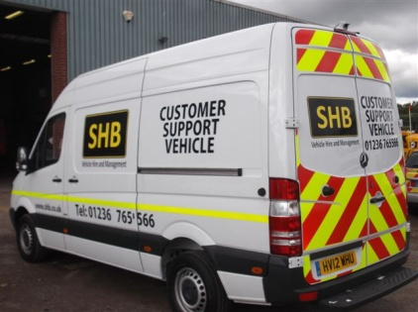With a focus on keeping their customer’s mobile and reducing non-productive time SHB’s dedicated team of over 55 mobile technicians carry out on-site repairs and maintenance to their own and their customer’s fleets. They are authorised by leading manufacturers to carry out their own servicing and warranty work and many of their vehicles carry vehicle diagnostic systems enabling them to repair vehicles that would otherwise require dealer attention. SHB’s local depots also have full workshop facilities providing full servicing, inspections, repairs, MOTs and major breakdown work.

The Management Team is dedicated to a system of quality, in March 1992 SHB was the first vehicle hire company in the country to be awarded the BS5750 Certificate (now replaced by ISO 9001:2008) which they have maintained to this day. In 2012 they achieved ISO18001 (Health & Safety) and ISO14001 (Environmental) in January 2013 and are one of the only vehicle hire companies in the country to hold all three simultaneously.

SHB work with their employees, customers, suppliers and the local communities where they operate to ensure they have a positive impact in relation to economics, social and environmental activity.

SHB are able to provide a true one-stop-shop approach to vehicle management and supply tailored flexible solutions 24/7, 365 days of the year which was proven in their award of the Van and Truck Rental Company of the Year at the Commercial Fleet Awards 2015 and being the Official Supplier for the renowned Farnborough International Airshow 2016.

SHB are also accredited to BVRLA, FTA and Van Excellence as well as being members of the Road Haulage Association and continually operate to the standards and expectations of these organisations.

SHB recently gained the FORS Silver accreditaion at their Heathrow depot and are currently working towards gaining the Silver accreditation at their other depots for 2017. For added security against cyber threats they have also registered with the Government backed scheme, Cyber Essentials.

[www.shb.co.uk](http://www.shb.co.uk)

**The Next Steps**

Acklea will be operating as a division of SHB so this will be very much business as usual with the same contracts within the business and numbers etc. SHB looks forward to meeting with you in the near future and exploring our future relationship but, in the meantime, if you have any immediate questions or queries please do not hesitate to contact us at our Headquarters based at Romsey on 01794 511458 or via the below:

Paul Street, Managing Director, Email: [p.street@shb.co.uk](mailto:p.street@shb.co.uk)

Nicky Simpson, Commercial Director, Tel: 07810 773869, Email: [n.simpson@shb.co.uk](mailto:n.simpson@shb.co.uk)

Martin Potter, General Manager, Tel: 07791 414692, Email: martin.potter@acklea.com

Richard Evans, Customer Services Director, Tel: 07801 317056, Email: [r.evans@shb.co.uk](mailto:r.evans@shb.co.uk)

Yours faithfully

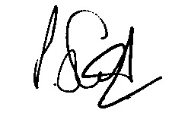

Paul Street

Managing Director

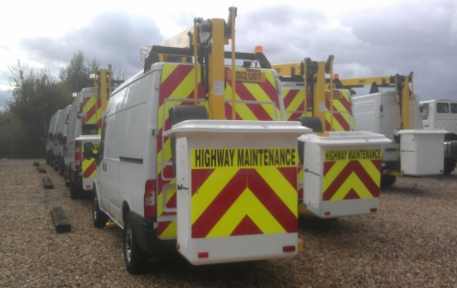SHB Hire Limited

